Loading The Dataset

|  |  |
| --- | --- |
| Team ID | PNT2022TMlD06631 |
| Project | Global Sales Data Analytics |
| Roll No | 61071911138 |

Using This Dataset, we have to Analysis the data in IBM Cognos for Data Visualization

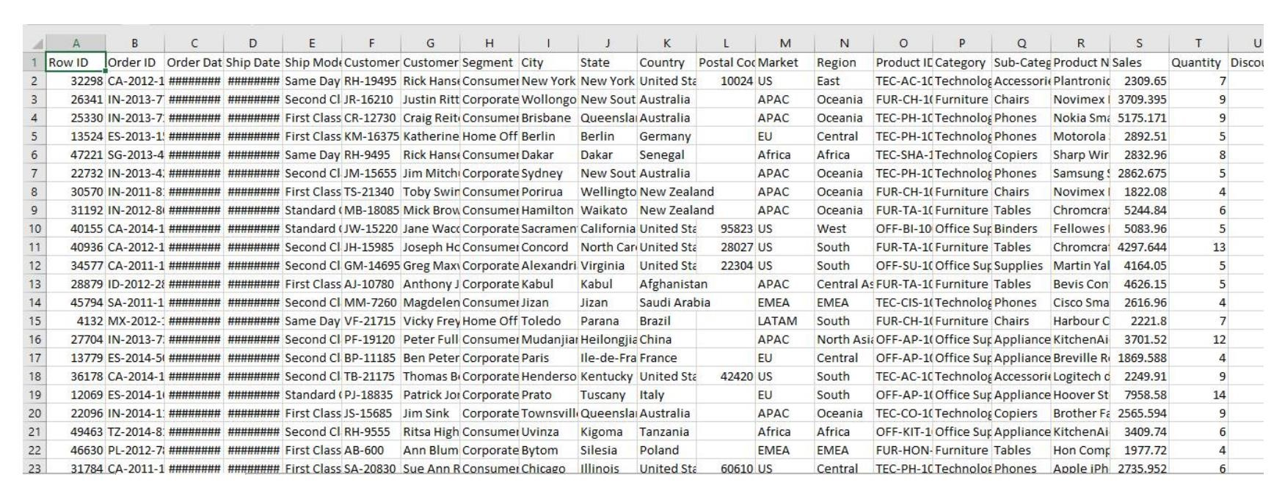

Uploading the Data for that select Upload Data

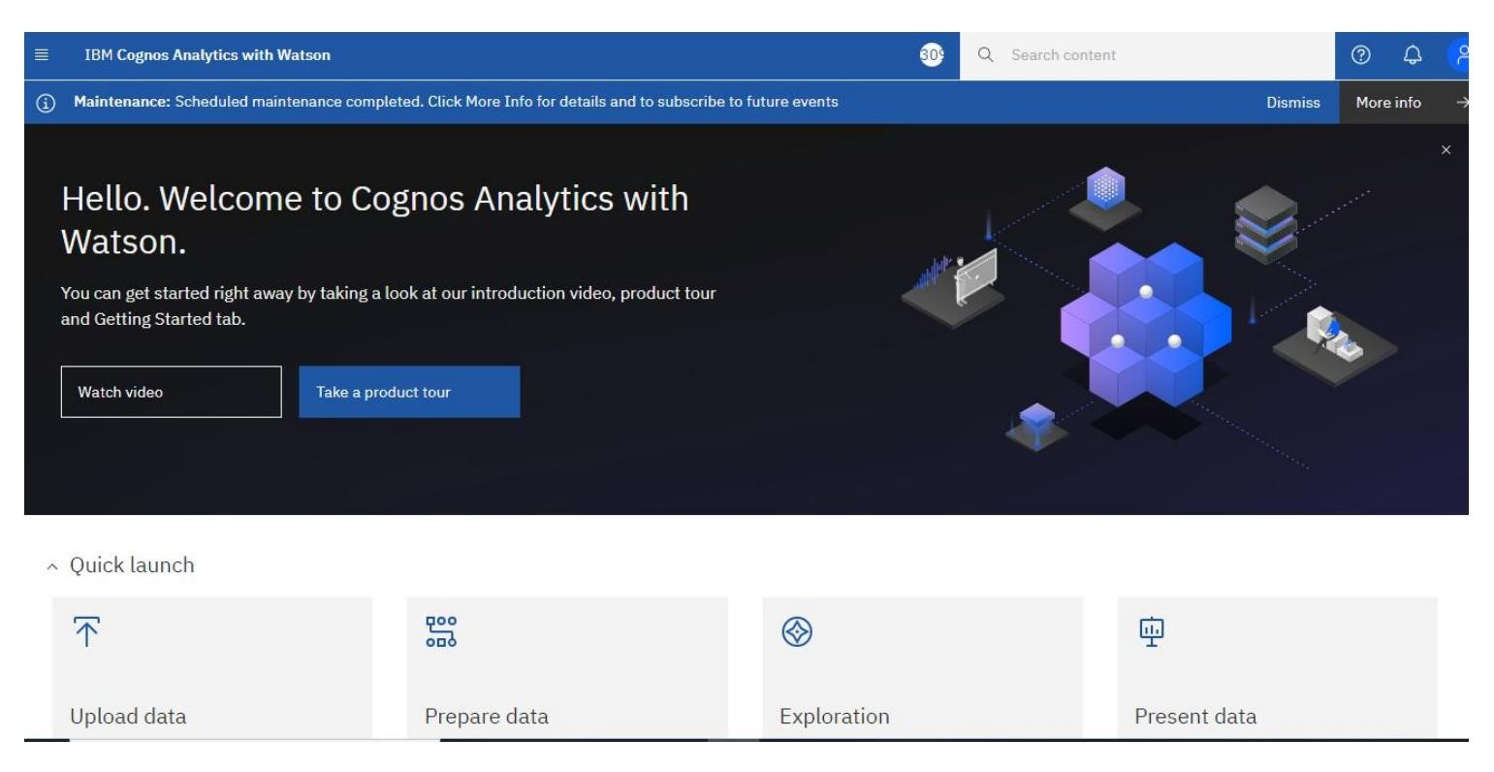

After the Upload the dataset, it will be Loading and uploaded Successfully

